ENGR 421 Homework 4

Umur Demircioglu

64609

* In this part of the code I imported the libraries and divided the data into train, test sets. I also initialized origin and bin width as given in the homework document then using these I found my left and right borders.

* Here I defined the regressogram function using the formula below. Then I used this function inside a for loop to create the g array which my p_hat. Then I plotted the results and datapoints.

* I also defined RMSE function using the formula below. I checked every interval test I subtracted the y values of test datas (only if they are inside the desired borders) from my g array. Then I divided the result to 33 and took the square root of the it.

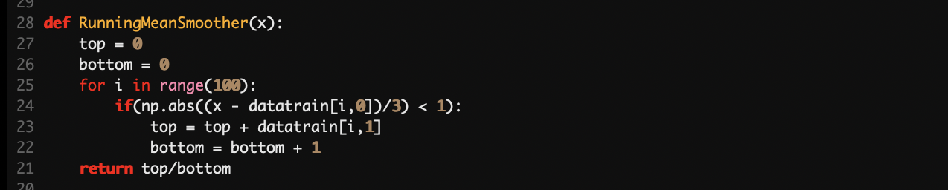

* Here I defined the runningmeansmoother function as shown in the formula below. Then used this function by giving data_interval. Then ploted output using the array g1 that I created inside a for loop which loops through data_interval.

